Vendor Registration Process
- From Vendor Registration page (https://cernerusers.workoutloud.com/Event/Exhibitors-NARUG_2023) Click Register
- Choose appropriate response
  - 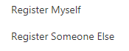
- On Attendee section, please fill in all pertinent information on the next page for the person you are registering, whether that is you or someone else
  - 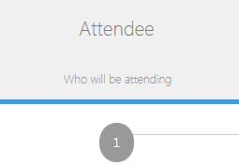
- The next page is Pricing
  - 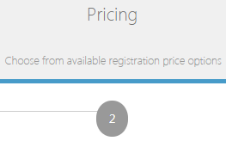
- Please choose the sponsorship level you desire.
  - There are 3 levels available, a couple of optional items
    - Main levels
      - Level 1 - $5000
      - Level 2 - $3000
      - Level 3 - $1500
    - You will add additional attendees later
- At the bottom of this page are a couple of Optional items
  - Event 1 - $500 - To sponsor either of our Monday or Tuesday evening events.
  - Evening Entertainment - $75 - If you are bringing someone who is not one of your booth attendees.
- After clicking next, you can now add your additional attendees (No Cost depending on plan) by clicking:
  - 