**Intros with S&P Team**

**Why this call**

* + "We are all in this together".
  + Because of the constant state of flux and because we are still in early stages, collaboration is so important
  + Want this to be a space for Pharmacy colleagues across the Cerner spectrum for issues and brainstorming
  + "Live" uCern thread

**Successful ED Scanning**

* + **Scan everything housed in the ED Pyxis cabinet** – what actually exists and what is being used
  + GI Cocktail
    - Make sure to match the ingredient throughout CPOE to formulary
    - Will they scan each ingredient?
    - Will it be a kit?
    - Pre-compounded bottle with specific label?
  + BULK meds – Barcodes on all of them?
  + Profile versus Non-Profiled
    - Advantage to profile – more accurate barcode scanning
  + Really work on APA (focus on QuickOrders, PowerPlans)
  + Banana Bag – Helpful to use intermittent CPOE IV sets
  + Insulin, Abx sets versus premixes
  + Charging for Kits
    - What is in the kits?
    - Will these be scanned in moment?
    - How will these be charged?
      * Manual sheet?
      * From scanning?  Recommend COA

**DRC Content Reset**

* + Ability to review groupers and overwrite customized content using the Multum Dose Range Checking Content Updates wizard

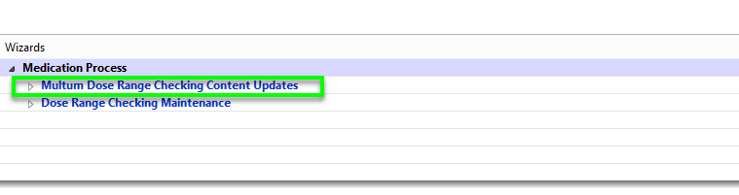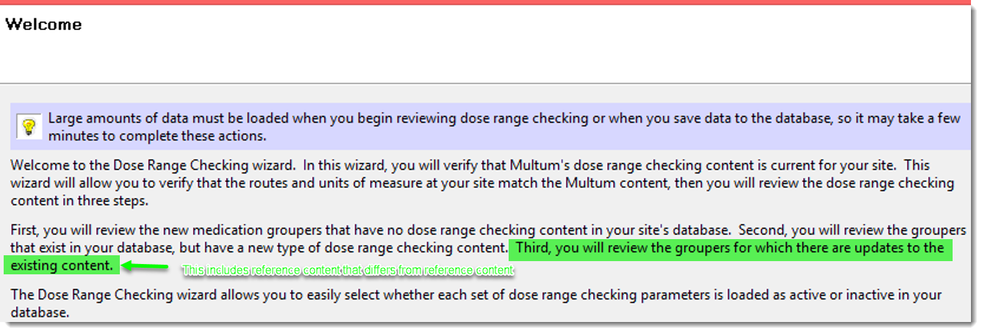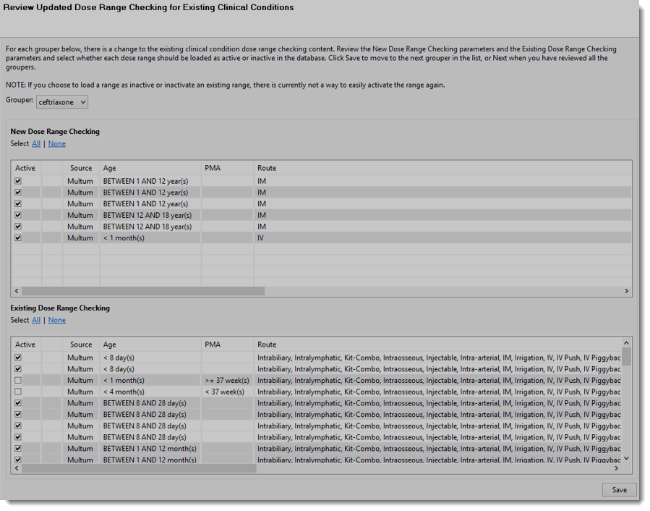





* + Content Manager allows export DRC content between domains which saves time and prevents one-off mistakes during duplicate manual updates
    - **Important caveat**: Multum version must be the same between the domains
    - [Content Manager DRC Import/Export Instructions](https://nam12.safelinks.protection.outlook.com/?url=https%3A%2F%2Fwiki.cerner.com%2Fpages%2Freleaseview.action%3FspaceKey%3Dreference%26title%3DUnderstand%2520Content%2520Manager%2520Dose%2520Range%2520Checking%2520(DRC)%2520Import%2520and%2520Export&data=05%7C01%7CIris.AlRoy%40spconinc.com%7Cc907007471bf4ae0bd6708da9e2ebb9a%7C87242dbc2cd441818345f860f99693f7%7C0%7C0%7C637996220917306571%7CUnknown%7CTWFpbGZsb3d8eyJWIjoiMC4wLjAwMDAiLCJQIjoiV2luMzIiLCJBTiI6Ik1haWwiLCJXVCI6Mn0%3D%7C3000%7C%7C%7C&sdata=0VgRvOyFYfr3arfzYacTvZtBJ3E9wf%2B2vf1VR%2FAwDVU%3D&reserved=0)

**Biosimilars**

* + Not a generic and not a new drug
  + Biosimilars drugs have no clinically meaningful differences
  + Huge price difference between biosimilar products
  + "Purple book" FDA's list of biological products
    - Great way to see if there is a biosimilars and is up to date
  + Authorizations : Cerner have order level authorization level functionality coming out
    - Doesn't work well with Win32 registrations
  + Order biosimilar by referenced product name and include on OEF with a free-text field to include biosimilar name
  + Links
    - [FDA: What is a biosimilar?](https://nam12.safelinks.protection.outlook.com/?url=https%3A%2F%2Fwww.fda.gov%2Fmedia%2F108905%2Fdownload&data=05%7C01%7CIris.AlRoy%40spconinc.com%7Cc907007471bf4ae0bd6708da9e2ebb9a%7C87242dbc2cd441818345f860f99693f7%7C0%7C0%7C637996220917462810%7CUnknown%7CTWFpbGZsb3d8eyJWIjoiMC4wLjAwMDAiLCJQIjoiV2luMzIiLCJBTiI6Ik1haWwiLCJXVCI6Mn0%3D%7C3000%7C%7C%7C&sdata=o2ly79WQwISOUqtfUnHJDczkQpfbjS9Z2qRamIceCFU%3D&reserved=0)
    - [FDA: Overview of Biosimilar Products](https://nam12.safelinks.protection.outlook.com/?url=https%3A%2F%2Fwww.fda.gov%2Fmedia%2F151058%2Fdownload&data=05%7C01%7CIris.AlRoy%40spconinc.com%7Cc907007471bf4ae0bd6708da9e2ebb9a%7C87242dbc2cd441818345f860f99693f7%7C0%7C0%7C637996220917462810%7CUnknown%7CTWFpbGZsb3d8eyJWIjoiMC4wLjAwMDAiLCJQIjoiV2luMzIiLCJBTiI6Ik1haWwiLCJXVCI6Mn0%3D%7C3000%7C%7C%7C&sdata=KfyTHOFk9r16LLm5oorigtjyyYS3dP4%2BAdTETbnnPSo%3D&reserved=0)
    - [Purple Book](https://nam12.safelinks.protection.outlook.com/?url=https%3A%2F%2Fpurplebooksearch.fda.gov%2Fdownloads&data=05%7C01%7CIris.AlRoy%40spconinc.com%7Cc907007471bf4ae0bd6708da9e2ebb9a%7C87242dbc2cd441818345f860f99693f7%7C0%7C0%7C637996220917462810%7CUnknown%7CTWFpbGZsb3d8eyJWIjoiMC4wLjAwMDAiLCJQIjoiV2luMzIiLCJBTiI6Ik1haWwiLCJXVCI6Mn0%3D%7C3000%7C%7C%7C&sdata=1oJ5AZWB%2FZMmWFdvT3QcMuywoMyl%2BWusOVYMl8ylsHI%3D&reserved=0)

**Issue #1: Inner NDC not inactivating when primary NDC is inactivated**

* + Causing issues with scanning
  + Inner NDC not easily identifiable face-up

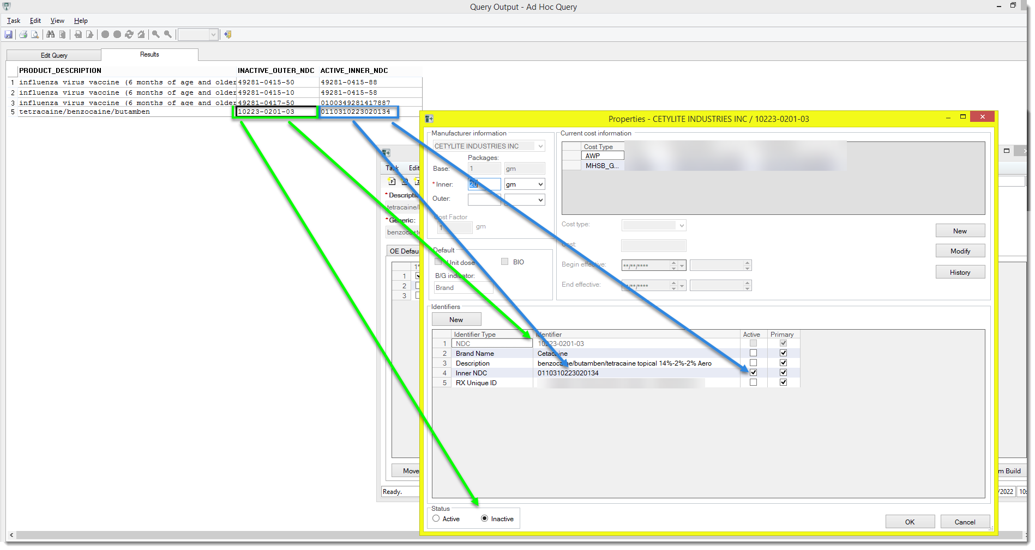

* + - Query provided (will email to the group)
    - <<inactive_outer_ndc_active_inner.txt>>

**Questions/Follow-ups**

* + Biosimilar – How do you make this more received? There is resistance. Payers are changing more often which is causing more issues
    - Revenue cycle is becoming more clinical driven
    - Pharmacy being brought in more and more into this space
    - Biosimilars managed within PowerPlans and clinical care team worked with providers to help drive choices
      * Value in Pharmacy team member who can serve as translator between clinical and finance
      * Providers get comfortable with drug they know a lot of about. Pharmacy can help drive conversations around other drugs
    - Logical challenges all well with getting the drug
    - More discussion for January call

**January 2023 Call**

* + Interplay with Pharmacy formulary and other applications (Mike)
    - Anesthesia, Oncology spaces
    - Limitations within these spaces
      * I.e. No two line items in Anesthesia
  + Use of clinical informatics tab in Powerchaart (Elizabeth VanHook)
  + What are others are doing with biosimilars/FDA approvals, commercial payer mandates etc professional acceptance of the change in treatment  mid cycle (Dianna Kane)